**Toolbox Trainers**

**Website Design Plan**

Realize Your Potential

Ella Qazi

Date: October 11th, 2024

Course: Web Programming I

Toolbox Trainers

Toolbox Trainers is an organization dedicated to helping aspiring scientists both new and old. They provide further skill development to aid people looking for jobs in standing out amongst their peers. They do this by offering supervised paid part-time internships to those looking to work in various scientific fields.

The Website

Purpose

The purpose of Toolbox Trainers is to prepare future workers for a career in their preferred scientific field. They offer more hands-on training than a typical college or university. Toolbox Trainers provides a unique opportunity to those who happen to cross its path.

Target Audience

The target audience of Toolbox Trainers is any pot-secondary school graduate who wants to gain more experience before heading straight into the job market.

Planned Pages

*Home*

The “Home” page will work as a friendly introduction to the organization as a whole. It will include descriptions of the work done at the organization, as well as well-known interns and employees, to provide a sense of community and showcase the strengths of Toolbox Trainers.

*About Us*

The “About Us” page will provide information about the CEO of this organization. It will also display the history of Toolbox Trainers, including the types of people it has helped. This page will include many images of the workspaces provided by the organization.

*Programs and Fields*

The “Programs and Fields” page will showcase the various fields that Toolbox Trainers offers programs for, as well as their prerequisites and expected pay.

*Sign Up*

The ‘Sign Up” page will be an easily accessed page to allow those who are interested to sign up for one of Toolbox Trainers’ many programs.

*Hours*

The “Hours” page will let inquirers know when the main building is open, as well as when the secondary buildings are.

*Contact Us*

The “Contact Us” page will allow people to contact one of the receptionists if they have any comments, questions, or concerns. This helps build a healthy relationship between the Toolbox Trainers team and the general public.

Logo



This logo is a red toolbox with 2 uppercase letter Ts on it, representing the name, “Toolbox Trainers”. This image was created by Ella Qazi, who gave permission to the organization for use in the logo.

Colour Palette

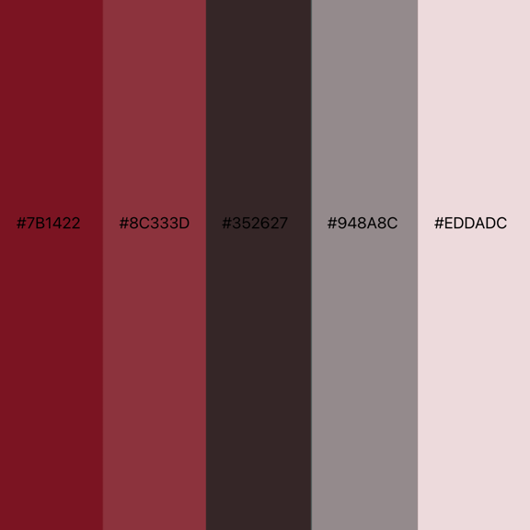

This colour palette was created by Ella Qazi, who gave permission to the organization for use in this website. The reds used represent passion and ambition. The black, grey, and off-white are reminiscent of popular monochromatic colour schemes that are frequently used today.

Website Banner

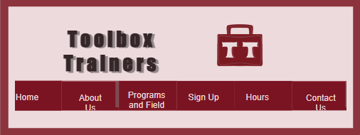

Mobile Layout

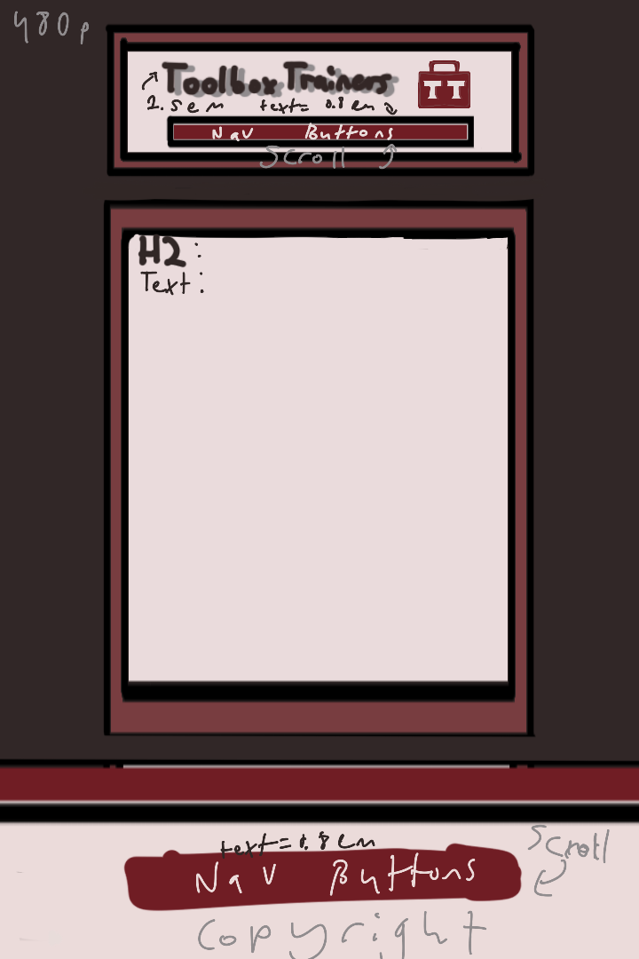

Desktop Layout

